This guide will help you think through and report on a potential self-evaluation that you might undertake of an FECOA-supported project. This will support the development of a case study.
Before your project starts please complete the table below, answering all of the questions
Project Planning Template
What is the title of your project?
Developing Parental Engagement

What is the main aim of doing this project?
Setting up and running a Games Library during and after school, and redevelopment of the school Forest Room to provide a supportive, quiet environment for staff to work in and meetings to take place with parents and professionals.

What would you like to change in your setting to support the project?
Parents are quite distant in their approach to school. Some do not come to school as their child arrives by school transport, others come to drop off/collect from the school site, but do not necessarily have positive memories of school. We want to change parent’s perceptions of school and to build their confidence in the way they support and interact with their child.
The school environment needs to be more welcoming and supportive to all parents, regardless of their previous experience or education.

How will you achieve this and make the difference needed?
We need to create a space that is warm and welcoming for parents to come into school. An area where they can bring younger children and where it is not stark and sterile, but welcoming so they can come into school. The room will be a place where parents can have confidential conversations with school staff or professionals, without feeling intimidated. Developing the Forest room will also provide an additional space for staff to work in comfort, without distraction. In order for this to happen, the room needs to be painted, have an electrical socket fitted and contain resources / furnishings that make the room more accessible / comfortable.
To make a Games Library, a number of games, for all school ages will need to be purchased. Provision will need to be put in place to run the library at lunchtime and after school, so that children can play the games with school staff, or to choose a game to share at home with their parents / family. The games library will need to be launched with the children and parents, taking into account the games suggestions from the children. Regular reminders will need to be provided for the children and parents to keep the momentum of the library going. Children will have regular access to the games, so they are then enthused to take a game home to share with their family.

What would you like to be the main outcomes for the children in your setting?
With the set up and running of the games library, we would like parents to engage with their children, spending quality time together as a family, where conversations take place and children are encouraged to interact and take turns. Playing the games will help develop some of the children’s language and social skills. As it is a library, it provides free opportunities for families to interact together without relying on the financial ability to purchase games. Developing the children’s turn taking and language skills will have a positive impact on their educational development.
Using the Forest Room for additional staff workspace will enable staff to work without interruption, which should enable higher quality lessons to be planned; this will benefit the children. Using the room for meetings with parents and professionals, will also have a positive impact on the children. Parents will be able to have confidential conversations, without their children being present, which may result in higher levels of engagement and focus from the parents.

Who will you work with to implement your project?
To implement the project, work will need to be completed with the school staff, children and parents. Children will be able to contribute their ideas of different games that they would like to play. Staff will support in the project by planning the development of the Forest Room, but also help to run the Games Library at lunchtime and after school.
Parents will be asked for their feedback about the games and their family experience using them.

How will you know success?
Parents will develop a greater number of positive school experiences. Children will spend quality time with their families and feedback received will be positive. Staff will be able to work / meet with parents and professionals without interruption and confidential conversations will be able to take place.

What do you hope to learn?
I hope to learn new, effective ways of developing greater levels of parental engagement. I would like to be able to develop key areas within school to be multipurpose, but effective.

After your project ends revisit your project planning table (above) and complete the table below, writing a brief account of your project and its outcomes
Project Reporting Template
Your name and role: Mrs Claire Scullion – Headteacher of Kinderley Community Primary School

Your setting: Kinderley CP School is a very small primary school. It is situated in a village on the outskirts of Wisbech. The school has 43% Free School Meal and 23% SEN. Over 25% of the children travel to school by School Transport, meaning a number of the parents are rarely seen. As the school is the most northerly primary school in Cambridgeshire, a number of the pupils travel across the border from Lincolnshire. The village of Tydd St Giles contains a number of large family homes, but also a development of social housing, where a number of school pupils live.

Introduction & summary of project: The aim of the project was to develop the level of parental engagement. For this to happen, the school wanted to set up and run a Games Library during and after school, and redevelop the school Forest Room to provide a supportive, quiet environment for staff to work in and for meetings to take place with parents and professionals.

Project implementation: The children were fully involved in the planning stage of the Games Library. They shared ideas of games that they would like and staffing was planned to support the running of the library. The games library was launched to the children during an assembly, ensuring that all of the children received the same message. Information was also shared with parents through the school weekly newsletter, outlining the days that the library would be open and how it would work. The age range of games purchased varied from 3yr-11+, so that there were games that were suitable for all ages. This would ensure the inclusivity of all members of the school community.
Once the library was running, regular reminders were provided either through the newsletter to parents, or during an assembly. An evaluation form was also provided for parents to complete, requesting feedback on the effectiveness of the project.
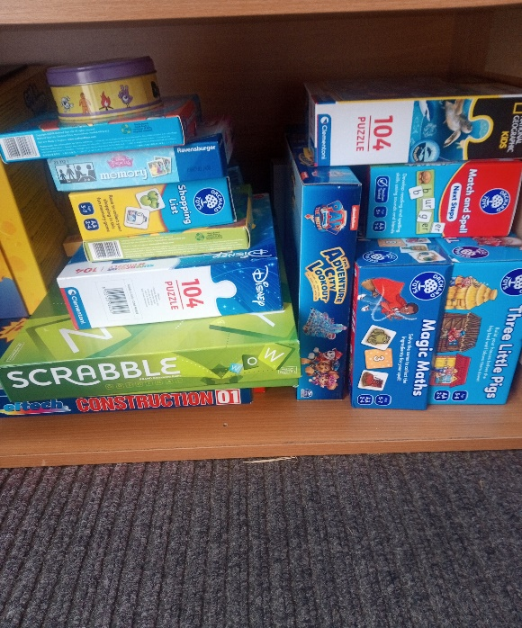
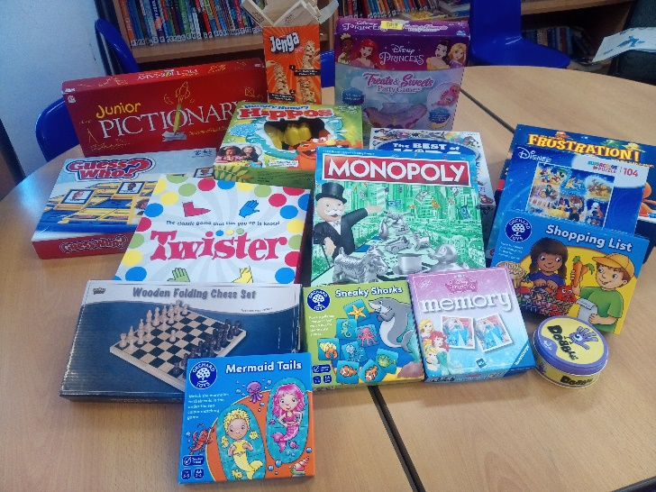

Feedback from parents stated that the games were played on numerous occasions as they were so positive: We adapted the rules on the game; the first to obtain 5 cheese portions is a quick aim, resulting in the game being over quite quickly. We played it every day! Eva looks forward to Mondays! Great feature!
The games library ran for two lunchtimes and it was often the same group of pupils that accessed it for this time. However the children enjoyed the company, conversation and support of the staff members involved.
Due to staff illness and COVID, the games library did not run for a short period of time. This enabled some money to be available at the end of the project. It was redeployed to further support parental engagement of the new Reception parents. The school will be rolling out the Read, Write, Inc systematic, synthetic phonics scheme in September 2022. As part of the New Parents Meeting, information was shared and resources shown for the new scheme. This heightened parents awareness of how they would be able to support their child with their reading and to see some of the resources that would be used.

The Forest Room had previously been used as an additional storage area. Once it was emptied and repurposed for a meeting / work room for staff and parents, it had an immediate positive impact. Due to the layout of the school, in order for any parents to meet with myself, the Headteacher, they have to walk through one of the classrooms. This could impact them negatively if they have bad school experiences, but could also unsettle the children. However, now that there was a room that confidential conversations could easily take place in, this meant that the disruption was instantly removed.
Staff could work in a quiet room, with a charging point for their laptop, to plan their lessons or meet with professionals. The school SENDCo reported that The forest room has been repainted and is now a clean and attractive work space. The addition of electrical sockets has enabled staff to work and conduct remote meetings effectively and for extended periods without needing to worry about battery power. It has also been used as an inviting space in which to bring parents to discuss SEN issues.
By having a space for the SENDCo to work in, enables her to focus on identifying children correctly who are on the SEND register and how to offer that graduated response, the pupils have a better offer in school.

Conclusions:
The original aim of the project was to develop parental engagement within the school. One of the main barriers that we came across was that a number of our children do not come to school with their parents, but instead, they come to and from school on school transport. This meant that we do not have opportunities to see and engage with the parents. However, by running the library at lunchtime, children who travelled on school transport did not miss out. They still had the opportunity to either play games at lunchtime with school adults or their friends, or they could select a game to borrow and take home at the end of the day.
Another barrier that we had was staffing and COVID. After the library was launched, within a month, the school suffered from a significant outbreak of COVID. The classes were separated and any games that were borrowed and returned were then quarantined. We could not open the library at lunchtime to be accessed by children from a variety of classes at the same time and we also had several weeks where there were no available adults to run the library.
A number of the parents were also very reluctant to enter into the school building. Having the weather to display the games outside at the end of the school day would provide alternative ways to promote the library.

Feedback & suggestions for the future:
The feedback that we have received from all of the parents has been incredibly positive. The cost of living has increased significantly and parents / carers would not necessarily be able to find the money to purchase games for their children to play. Having the games library provides them with an opportunity to borrow a wide variety of games / puzzles at no cost to the family.
If we had the opportunity to complete the project again, I would provide more opportunities for the games to be borrowed from the playground rather than the school library; this will encourage greater parental involvement.
For the Forest Room, I would request shorter deadlines for when elements should be completed. We have not had the opportunity to make the most of the room this year, seeing the impact that it has had on staff, parents and children, as it has taken much longer to complete the work on it.
I would recommend either element of the project to others, especially the games library. Providing access to the games, enables families to spend quality time together, but at no cost to them.

